MACHINE LEARNING AND BIG DATA – ASSIGNMENT 2 – MULTIVARIABLE REGRESSION

Multivariable regression is actually pretty similiar to linear regeression. The only difference from that is we have “mutliple varibales (parameters)”.

Because of that, we will now have a model with multiple parameters

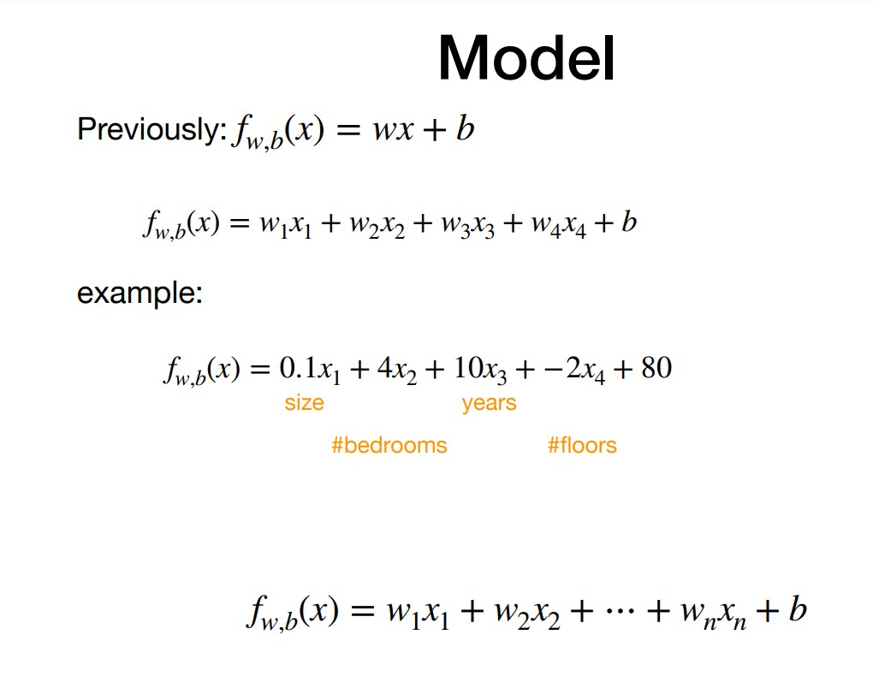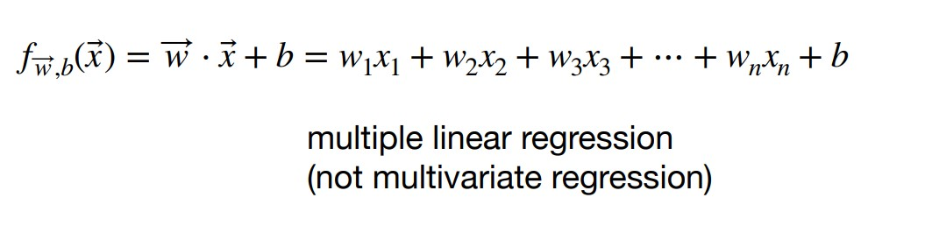

Here is how each of our variables are respect to the target

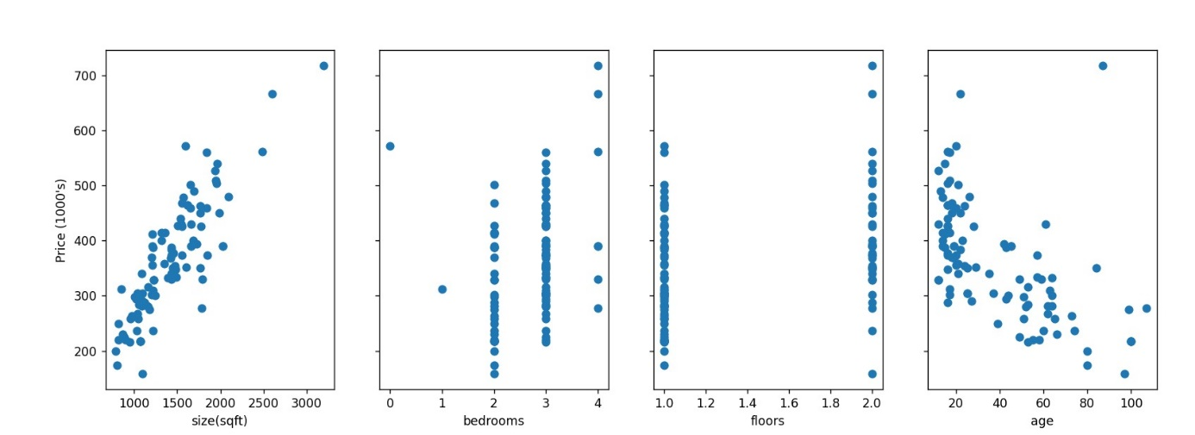

I will explain my functions one by one:

* Z-score
* Compute cost
* Compute descent
* Compute gradient descent

1. Z-score

Here, we will use this z-score function to “normalise” our X inputs

When constructing our model, we will normalise X values (which we got from houses.txt file) and use normalised X values

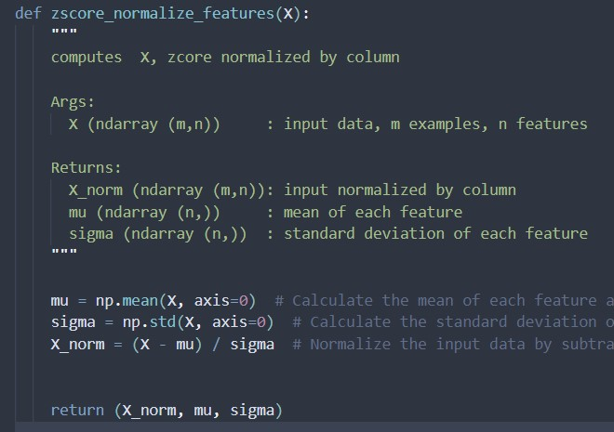

A SMALL BUT STILL AN IMPORTANT THING TO POINT OUT is that, we will also use the “sigma and mu” values in smaller sample examples…

1. Compute Cost

Compute cost, calculates the error… when we say “error” we mean “the ‘general’ rate how far our ‘estimations’ are from the ‘target’ ”

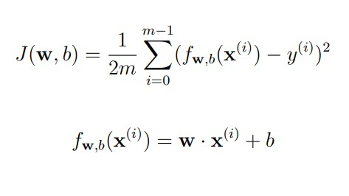

Here is my compute cost function…

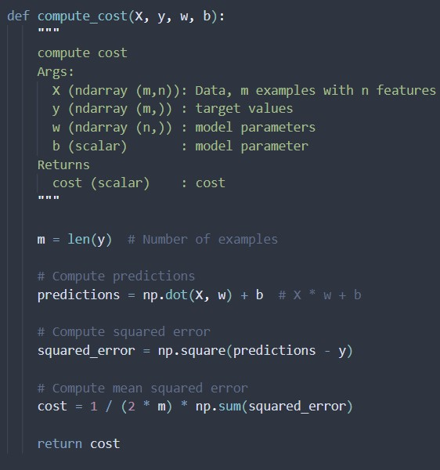

1. Compute gradient

Here, we are taking the derivative of the cost function (cost function is coming from compute_cost)

However, it is a little bit different to “finding derivative in multivarible” than linear (single variable function)  
Since we have multiple variables, “respect to which one” will we be taking the derivative?

* Answer is, respect to all…
  + Taking derivative of each variable is taking “partial derivative”s of cost function
  + If we take the derivative of all variables (if we find all partial derivatives) (after summing them) we will have the “derivative of cost function” 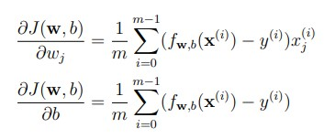

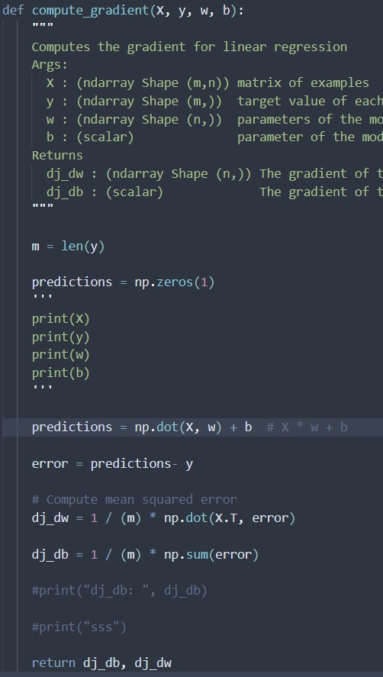

1. Compute gradient descent

Gradient descent is same as linear regression… We just need too apply compute_gradient multiple times until we reach the best w and b values (lowest cost rate)

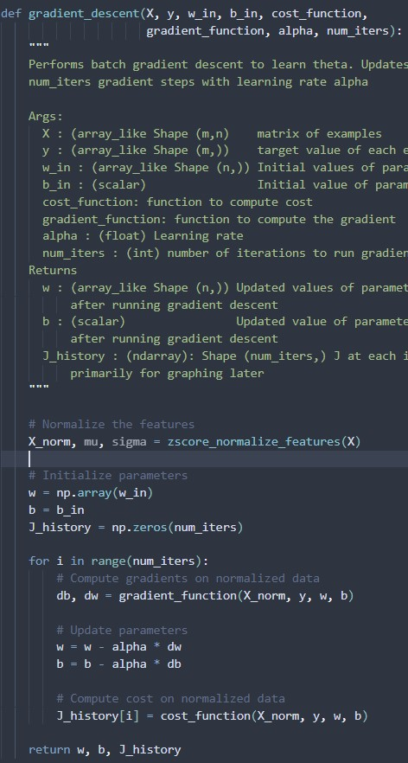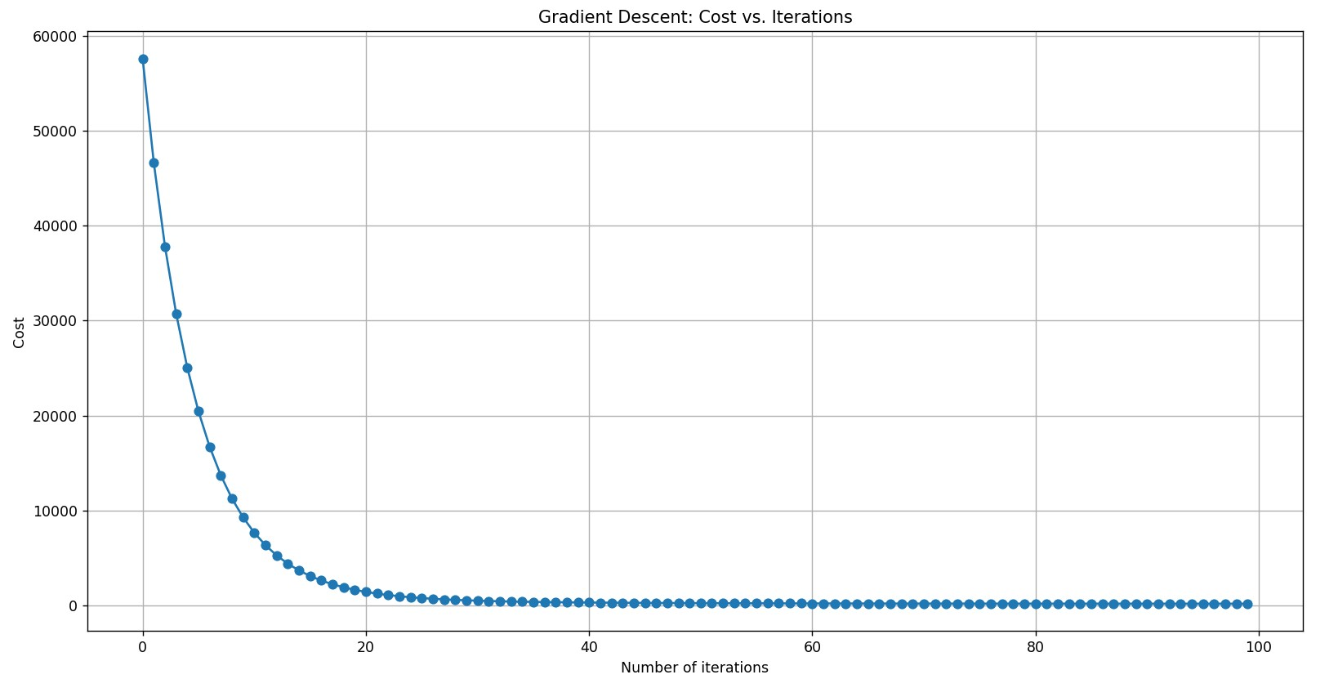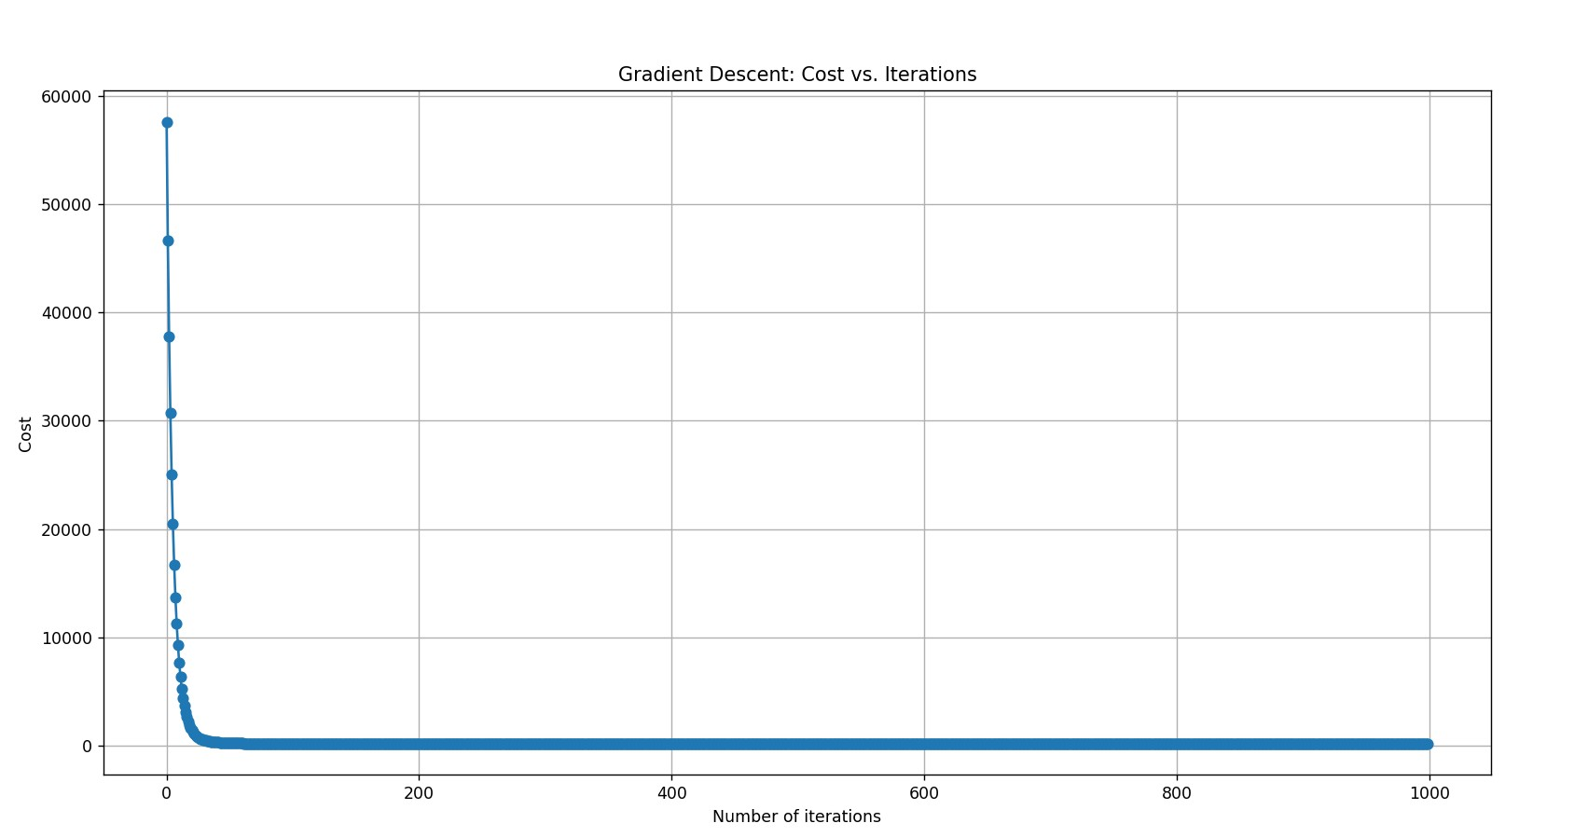

Here is how my model performs after everything

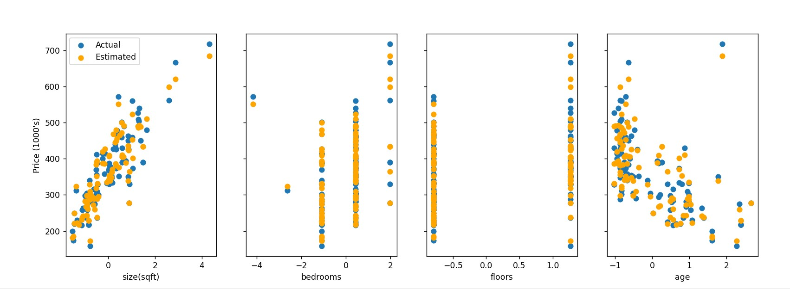

Proof that it passes tests:

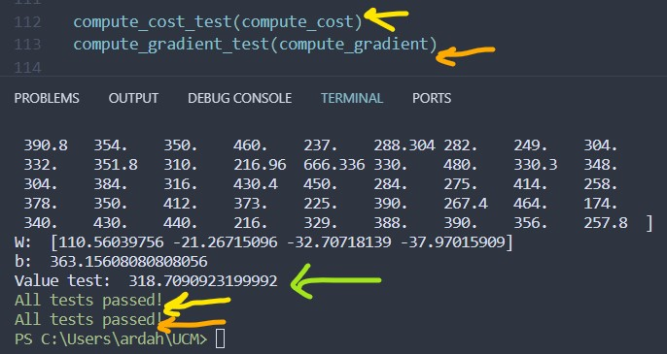

Here is my whole code…

Multi_linear_reg.py

